Title:
A Case Report of Ruptured Ectopic Pregnancy with Negative HCG Blood Test

Running Title:
A Case Report of Ruptured Ectopic Pregnancy with Negative HCG Blood Test
Authors:
Marzieh Talebian (Corresponding Author): OB& GYN specialist and perinatologist, department of OB& GYN, Kashan University of Medical Science, Shahid Beheshti hospital, Kashan ,Iran. Email: talebianm861@gmail.com, Cell Phone: +989364291518
Zohreh Talebi Mazreshahi: OB& GYN resident, department of OB& GYN, Kashan University of Medical Science, Shahid Beheshti hospital, Kashan ,Iran
Elham Khosravi Mashizi: OB& GYN resident, department of OB& GYN, Kashan University of Medical Science, Shahid Beheshti hospital, Kashan ,Iran
Nafiseh Khalili: OB& GYN resident, department of OB& GYN, Kashan University of Medical Science, Shahid Beheshti hospital, Kashan ,Iran

Abstract
Introduction: Although 1% to 2% of all pregnancies are ectopic, ectopic pregnancy (EP) is the most frequent obstetrical disease leads to maternal mortality and morbidity at first trimester. The basic diagnostic method of EP is the human chorionic gonadotropin (HCG) test and transvaginal ultrasound. There are some rare EP cases with negative HCG blood test.
Case presentation: A 31-years old woman referred to the emergency department with hypogastric, periumbilical, and right upper quadrant intermittent pain and vaginal bleeding and prior history of EP 7-months ago that treated with methotrexate and her intra uterine device had been removed at that time. Her last menstrual period was undetermined. Although HCG blood test-qualitative was negative (2.08 IU /ml),ultrasound examination showed an 43×53 mm echogenic, heterogenic complex solid mass in the left adnexa and a large amount of echogenic fluid demonstrating hemoperitoneum. Taken surgery because of the exceeded abdominal pain revealed active bleeding in the left salpinx due to ruptured EP.
Conclusion: Management of patients suspected of EP with negative HCG-blood test is difficult. In this uncommon cases in emergency, computed tomography, ultrasound and diagnostic laparoscopy or laparotomy can improve prognosis of patient.
Key words: Ectopic Pregnancy, HCG Blood Test-Qualitative , Shock, Transvaginal Ultrasound, HCG Blood Test-Quantitative

Introduction
When a blastocyst implants in another site of the endometrial cavity EP occurs. Although only 1% to 2% of all pregnancies are ectopic, it is one of the important obstetrical complications, which leads to serious maternal mortality and morbidity. A study of a single large health network from 1997 to 2000 demonstrates a rate of 20.7 per 1000 pregnancies (1). Complications from EP and the related treatment procedures may cause recurrent EP and future infertility. Among pregnant women referring to an emergency department in the first -trimester with bleeding and/or pain, the range of EP is 6 to 16 percent (2). EP is the most common obstetrical cause of maternal mortality at the first trimester of pregnancy and accounts for 4 to 10 percent of all pregnancy-related deaths. In older women the risk of EP increases (3).The location of EP in 96 percent of cases is the fallopian tube. Rupture of tubal EP can lead to hemorrhagic shock, then the early diagnosis of EP is critical. Before rupture, an EP is diagnosed based on laboratory and ultrasound findings. The primary laboratory test is the HCG blood test- quantitative. HCG is a pregnancy hormone, which is detectable in body fluids within a short time after embryo implantation. The presence of HCG in urine is the basis for home pregnancy test. A variety of isoforms of HCG which are detectable in urine, containing intact HCG, nicked forms, free α and free β subunits of HCG, also the β-core fragment of HCG (βcf-HCG; this breakdown product of HCG found in urine only) (4,5). There are some rare EP cases reported with negative HCG blood test, therefore the negative HCG blood test can lead to missed diagnosis of EP. In these cases, tubal rupture and hemoperitoneum, and shock can occur.

Case presentation
A 31-year- old woman was referred to the emergency ward with hypogastric and periumbilical and right upper quadrant intermittent pain and nausea and vomiting begging from the morning of admission and vaginal bleeding (spotting) from one week ago after discontinuing oral contraceptive pills which had consumed it since 3 weeks ago. She was gravida3 para2 EP1 with a history of two natural vaginal deliveries and history of EP 7-months ago that treated with methotrexate and her intra uterine device had been removed at that time and HCG blood test-quantitative was serially checked and final test was 49 IU/ml six months ago. Her past medical history was renal stone and surgery due to cleft palate in childhood. Physical examination revealed vital signs with blood pressure 800/60 mm Hg and a pulse rate of 98 beats/minute. Abdominal examination showed tenderness in the right lower quadrant and hypogastric without guarding and rebound tenderness. Laboratory evaluation demonstrated a negative HCG blood test-qualitative. The Hemoglobin was 9.7 gr/dl and WBC was 13.2 × ${10}^{3}$ /µl. Six hours later, the abdominal pain increased, especially in the hypogastric and right upper quadrant progressively and blood pressure and pulse rate were 75/60 mm Hg and 110 beats/min and hemoglobin concentration dropped from 9.7 to 7 gr/dl. Ultrasound examination revealed a 43×53 mm complex solid mass in the left adnexal that was echogenic, heterogenic, and had vascularity and a large amount of echogenic fluid in the pelvic cavity demonstrating acute hemoperitoneum. During surgery massive hemoperitoneum and active bleeding at the infundibulum of the left salpinx due to ruptured EP were found and the right salpinx was normal. Left salpingectomy was performed. The HCG blood test-quantitative was 2.08 IU /ml. The patient was discharged after two days. Pathology results confirmed ectopic pregnancy (Figures 1, 2).

Discussion
EP is the most frequent obstetrical cause of maternal mortality at first trimester. If we don’t consider clinical features, serious mistakes will occur. History of regular menses will cause excluding EP in some cases but not in all. There is possibility of any menstrual cycle history in EP, amenorrhea lesser than 4 weeks or greater than 12 weeks was reported about 15% of cases, included the ruptured EP. Even sexual history is not reliable and may be problematic to exclude pregnancy risk. At least, there is a 10% chance of pregnancy in women reporting normal menses, and in those who reported "there is no chance that they could be pregnant" (6). Historical criteria are not successful to exclude pregnancy in emergency department patients. Transvaginal ultrasound and HCG blood test are the main diagnostic assays in EP. If we do not check the HCG blood test, EP will be confused with other diseases, like ovarian torsion, appendicitis, pelvic peritonitis, ovarian cyst, miscarriage. HCG blood test with laparoscopy and histological examination differentiate between them. Negative HCG in urine and blood test may cause incorrect diagnosis of EP. Consequently, the fallopian tube will be ruptured .EP with negative HCG blood test is rare. Relatively 1% of ectopic pregnancies have negative urine pregnancy tests and the HCG blood test lower than 20 mIU/mL. In intrauterine pregnancy, trophoblasts secrete HCG that during two weeks of fertilization blood levels rising 50–300 mIU/mL. When the HCG blood test is ≥25 mIU/mL, HCG in urine will be detectable. In intrauterine pregnancy, HCG blood test-quantitative level doubles relatively every 48–72 hours until 60–90 days after fertilization. This rise occurs in 71% of pregnant women with normal pregnancy and 15% of EP cases. Mechanism of low HCG blood test levels in EP is degeneration of trophoblasts, small chorionic villi produce HCG, abnormal HCG synthesis, and increased HCG clearance. In abortion cases, HCG - levels decrease relatively one-half in 48 hours and will be zero after several days (7). When there is a high level of βcf-HCG, it can make false- negativity in point-of-care and over-the-counter pregnancy tests (8-10).The “hook effect” for intact part or free β-HCG is the main cause. (5). The retrospective study about EPs showed in 25% of patients HCG blood test-quantitative was less than 1000 mIU/mL while pelvic ultrasound was suspected of EP. Because HCG assays are not sensitive, more diagnostic efforts are needed in unstable cases or high suspicious patients. In unusual features of EPs, diagnostic laparoscopy or laparotomy may improve prognosis of patients. Ultrasound and computed tomography can help to diagnose hemoperitoneum and adnexal mass.

Conclusion
EP is the most frequent obstetrical cause of maternal mortality in the first trimester of pregnancy. Relatively 1% of Eps have a negative urine pregnancy test and HCG blood level < 20 mIU/mL (6). The emergency physician should be aware that unexplained intra-abdominal hemorrhage or severe pelvic pain may be ruptured EP can present with a negative HCG in urine. Our case shows clinical diagnostic challenges for EP. We should not rule out EPs with negative pregnancy tests. If a pregnant woman has symptoms that may be EP, HCG blood test-quantitative cannot help to determine if ultrasound is necessary or not. In one study, relatively 25% of EP in the emergency department, the HCG blood test-quantitative was < 1500 mIU/mL, which was the traditional HCG blood test level that an intrauterine pregnancy can be detectable on ultrasound. The retrospective study on EPs have found out in 25% of patients HCG blood test-quantitative was < 1000 mIU/mL, while pelvic ultrasound was suspicious for EP (7). In uncommon cases of EP, ultrasound, computed tomography, and diagnostic laparoscopy or laparotomy can help to save patient life.
Conflicts of interest: The authors declare no conflict of interest on planning, researching, and submitting the manuscript.

References

1. Van Den Eeden SK, Shan J, Bruce C, Glasser M. Ectopic pregnancy rate and treatment utilization in a large managed care organization. Obstetrics and gynecology. 2005;105(5 Pt 1):1052-7.
2. Murray H, Baakdah H, Bardell T, Tulandi T. Diagnosis and treatment of ectopic pregnancy. CMAJ : Canadian Medical Association journal = journal de l'Association medicale canadienne. 2005;173(8):905-12.
3. Nybo Andersen AM, Wohlfahrt J, Christens P, Olsen J, Melbye M. Maternal age and fetal loss: population based register linkage study. BMJ (Clinical research ed). 2000;320(7251):1708-12.
4. Stenman U-H, Tiitinen A, Alfthan H, Valmu L. The classification, functions and clinical use of different isoforms of HCG. Human Reproduction Update. 2006;12(6):769-84.
5. Johnson S, Eapen S, Smith P, Warren G, Zinaman M. Significance of pregnancy test false negative results due to elevated levels of β-core fragment HCG. Journal of immunoassay & immunochemistry. 2017;38(4):449-55.
6. Brennan DF, Kwatra S, Kelly M, Dunn M. Chronic ectopic pregnancy--two cases of acute rupture despite negative beta HCG. The Journal of emergency medicine. 2000;19(3):249-54
7. Sheele JM, Bernstein R, Counselman FL. A Ruptured Ectopic Pregnancy Presenting with a Negative Urine Pregnancy Test. Case reports in emergency medicine. 2016;2016:7154713.
8. Gronowski AM, Cervinski M, Stenman UH, Woodworth A, Ashby L, Scott MG. False-negative results in point-of-care qualitative human chorionic gonadotropin (HCG) devices due to excess HCGbeta core fragment. Clinical chemistry. 2009;55(7):1389-94.
9. Nerenz RD, Song H, Gronowski AM. Screening method to evaluate point-of-care human chorionic gonadotropin (HCG) devices for susceptibility to the hook effect by HCG β core fragment: evaluation of 11 devices. Clinical chemistry. 2014;60(4):667-74.
10. Nerenz RD, Butch AW, Ashby L, Woldemariam GA, Gronowski AM. Evaluation of a semi-quantitative pregnancy device for susceptibility to interference caused by HCGβcf. Clinical biochemistry. 2015;48(12):815-7.

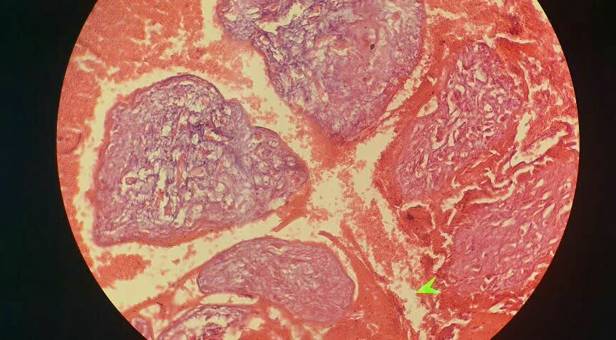
Figures 1, 2: chorionic villi are present characteristic with ectopic pregnancy

